**3.1 Implement a MATLAB function to plot the Airy disk.**

Code execution Instruction:

1. Run MATLAB script titled (qsn3part1.m) to generate all the Airy disk plots on a single figure handle (in different colors).

**Note:** The function “PlotAirydisk(lambda, NA)” computes the spatial intensity values after passing through a circular aperture, with the wavelength of light (lambda) and Numerical aperture(NA) as the inputs.

Mathematical background:

The intensity of an airy disk is calculated by solving the first order Bessel’s function.

$$I={\left(\frac{2J_{1}\left(x\right)}{x}\right)}^{2}$$

where, $x=\frac{2*π}{λ}*a*\sin\left(θ\right);$

$λ is wavelength$;

$a is aperture,$

$$θ is the angle between the distance between the screen to circular aperture and the point on the screen$$

Results:

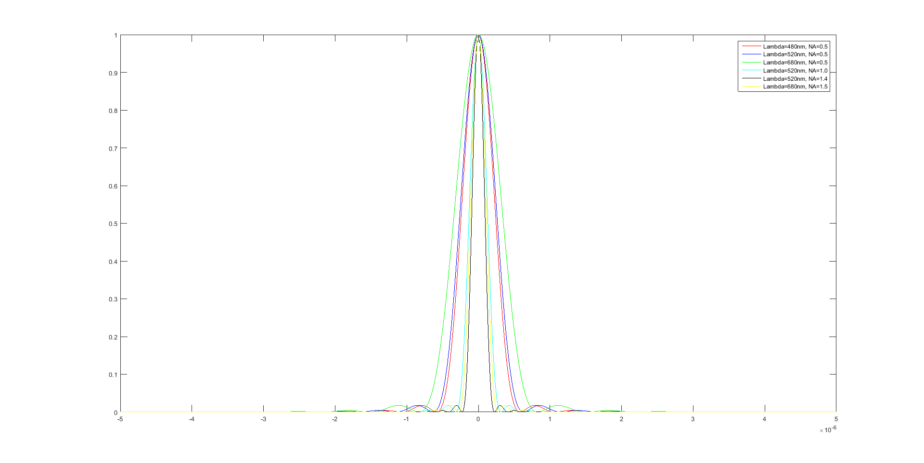The plot of airy disks with different wavelength and Numerical aperture combinations are as follows:

From the plot above, it’s clearly evident that the incident light wavelength and numerical aperture of the microscope, influences the radius of the airy disk.

On comparing the first 3 cases (as depicted in the legend), we can see that radius of the airy disk increases, with an increase in wavelength of light (while keeping the Numerical aperture constant) [from red to blue to green]. Along with that, we can see that radius of the airy disk increases linearly with an increase in wavelength (can be proved quantitatively, as well). This shows that the radius of the airy disk is directly proportional to the wavelength of light.

On comparing Case 2, Case 4 and Case 5, where the incident wavelength is 520nm, while the Numerical aperture increases (from 0.5 to 1.0 to 1.4), there is a notable decrease in the radius of the airy disk. This implies that the radius of the airy disk is inversely proportional to the Numerical aperture used.

From the above figure and analysis, we can say, that $r_{airydisk}$**∝ $λ/NA$**

**3.2 Fitting of the Airy disk using a Gaussian kernel**

Code execution Instruction:

1. Run MATLAB script titled (qsn3part2.m) to evaluate the radius of the airy disk as well as the standard deviation of the best fitted Gaussian kernel.

**Note:** The “findradius” function calculates the radius of the Airy disk, and the “gaussianFit” function determines the best fitted Gaussian kernel (for each of the 6 cases).

For each of the Airy disks plotted, a Gaussian kernel has been fitted.

From the earlier plot, it is clear that the mean of the Gaussian must be centered at distance of screen (y) = 0. The sigma is varied to obtain the best fit, by minimizing the mean-square error between the fitted Gaussian kernel and the Airy disk intensity profile.

For the 6 cases, the best Gaussian kernel fit (sigma) and the radius of the airy disk are tabulated below:

|  |  |  |  |
| --- | --- | --- | --- |
| **Sno** | **Input parameters** | **Radius of Airy disk** | **Best Gaussian Kernel Fit (sigma)** |
| 1 | $$λ=480nm, NA=0.5$$ | $$0.58 μm$$ | $$0.2045 μm$$ |
| 2 | $$λ=520nm, NA=0.5$$ | $$0.62 μm$$ | $$0.2215 μm$$ |
| 3 | $$λ=680nm, NA=0.5$$ | $$0.82 μm$$ | $$0.2895 μm$$ |
| 4 | $$λ=520nm, NA=1.0$$ | $$0.31 μm$$ | $$0.1110 μm$$ |
| 5 | $$λ=520nm, NA=1.4$$ | $$0.22 μm$$ | $$0.0795 μm$$ |
| 6 | $$λ=680nm, NA=1.5$$ | $$0.27 μm$$ | $$0.0965 μm$$ |

On comparing the radius of the Airy disk to the Sigma of the Gaussian Kernel, we can see that that the best fit Gaussian (Standard deviation (sigma)) is one third the radius of the airy disk, while the mean is centered at 0.

The fitting is optimal, and this can be verified by calculating the value of the Gaussian function at 3*sigma, which equals 0.011 (Peak amplitude) (ie very close to zero, first minima of the airy disk).

This standard deviation – radius relation dictates the optimal sampling frequency. Here, in order to be able to get reliable sub-pixel detection, we would require 3 pixels to cover the radius of one airy disk.